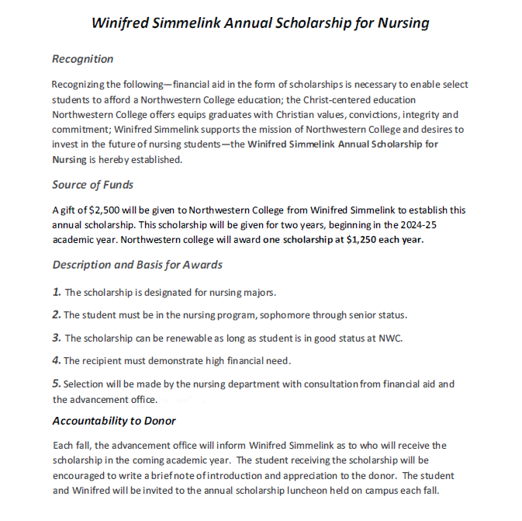
Winifred Simmelink Annual Scholarship for Nursing

Please complete the following, print, and submit to the Department of Nursing

Name | Current Year in  BSN program | Current CGPA | Renewal (Y or N)

Complete the following essay question:

Reflecting on healthcare practice today and the increasing use of technology, explain how you hope to demonstrate Christ-like caring to those you serve.

